Enhanced Ant Colony Optimisation using Genetic Algorithm to tune FOPID controller for Fractional Order Plant

Abstract: This paper presents a method to tune fractional order PID (FOPID) controllers by using a nested form of Genetic Algorithm and Ant Colony Optimisation (ACO). Conventionally, the parameters of an Ant Colony Optimisation algorithm have been found by using trial and error method. Our approach is to use a Genetic Algorithm to optimize the parameters of the ACO algorithm. The enhanced ACO algorithm is used to tune a FOPID controller by minimizing a multi-objective function. Simulation results show that the Enhanced ACO algorithm delivers better results than Genetic algorithms.

1. Introduction

Proportional-Integral-Derivative (PID) controllers are commonly used to obtain desirable performance parameters of various types of dynamic plant systems. In recent years, many electrical, mechanical and biological systems are being modeled using fractional differential equations. To tune plants that have fractional order transfer functions we require fractional order PID controllers.

Many algorithms have been proposed to tune FOPID controllers. Some of them are Genetic Algorithms, Ant Colony Optimisation, Fuzzy Algorithm, Evolutionary Programming and Particle Swarm Optimisation. Genetic Algorithm is an artificial version of Darwinian theory. It simulates the process of evolution and revolves around three important notions. They are Reproduction, Crossover and Mutation. Genetic Algorithm gives a well optimised output for a wide span of problems. It is governed by the
probabilistic conversion rules, making it less efficient for a given set of variables.

In the real world, ants use pheromone, which gets evaporated with time, to find the best route for themselves. The evaporation of pheromone is done because the ants keep on following the first trail with highest intensity of pheromone, thus diverging from the optimal solution.

The repetitive set of iterations are used to calculate the input parameters for ACO, till a desired output is reached. The output of the n^{th} iteration is referred for the calculation of the input of the (n+1) ^{th} input parameters.

The following sections 2 and 3 gives an in depth knowledge of Genetic Algorithm and Ant Colony Optimisation. Section 4 is about our proposed “Enhanced Ant Colony Optimisation”. Section 5 states the Multi-Objective function used in our algorithm. Section 6 contains all our simulations in accordance to our proposed algorithm.

2. Genetic Algorithm

Charles Darwin proposed the idea of natural selection, which states that only the fittest would flourish and the weaker population would eventually stagnate.

Genetic Algorithms are meta-heuristic algorithms, based on the process of Natural Evolution and Natural Genetics. Developed by John Holland, the goal of his research has been:
• To abstract and rigorously explain the adaptive processes of natural systems.
• To design artificial systems software that returns the important mechanisms of natural systems. [1]

As the initial set of instructions are completely randomized, Genetic Algorithm adapts according to the given environment by reproducing with each iteration. The fittest offspring are kept for the next iteration, where they act as the parents. After a certain number of cycles, mutation takes place. Mutation is done because their might me some useful genetic resources that may be skipped. Termination step only happens after an optimal solution is achieved for the given objective function.

Normal search techniques are more deterministic. Hence, for a small change in the fitness function, they have to be modified. This contributes to a more expensive redesign, as they are less flexible. Genetic algorithm has the property of self-restoration and self-guidance.
But Genetic Algorithm has an infinite sample space. Thus, when it is implemented for a finite region, the output of the system may not be accurate. Hence, further modifications are required for this purpose.
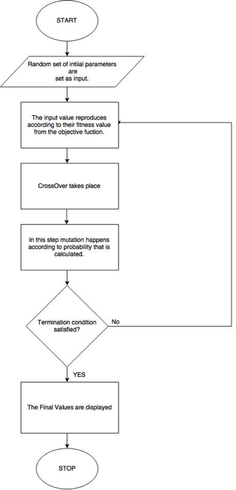
3. Ant Colony Optimisation Algorithm:

In this section , we see how the ACO algorithm is used to tune a FOPID controller for a given set of values of ant parameters i.e α,β and ρ.

The Ant Colony Optimisation (ACO) algorithm falls under the category of metaheuristic search algorithms. It can be used to find the shortest path between points on a graph or to minimise a cost function, based on the technique that ants use to find the best path to food from their colonies.

Ants travel randomly in search of food. When an ant finds food at a particular location, it retraces it’s path to the colony laying down a pheromone trail on its way. Other ants detect this trail and are likely to follow it to the source of food laying down pheromone along the way, thereby increasing the strength of the pheromone along the trail. The pheromone deposited along the trail gradually evaporates and thus its intensity reduces with time. Consequently, the longer the pheromone trail the lowers its attractive strength. An ant is more likely to take the path with the higher pheromone level although it might take a different path. As many ants repeatedly travel between the colony and the source of food the shortest path between the two is eventually revealed.

The ACO algorithm uses many of the same principles to find the minimum value of a cost function. In this paper the algorithm is used to minimise a multi-objective cost function which encapsulates overshoot, rise time, settling time and ITAE of a FOPID controller connected to a fractional order plant forming a unity feedback system. The design and use of the multi-objective function will be explained in greater detail later in this paper. The Ant parameters α,β and ρ determine how the algorithm will work for a given system.Here,α and β are the user defined parameters and ρ is the evaporation rate.

The algorithm is now explained as follows:

1. Initialisation:

Create a node matrix consisting the possible values of Kp, Ki ,Kd , lam & mu. These values are uniformly separated.
Create a probability matrix of the the size of the node matrix. Initially , each node will have an equal probability of being visited.
Create a pheromone matrix to keep track of the pheromone accumulation and evaporation.
Create an ant matrix to keep track of the nodes visited by the ‘m’ ants in the each iteration.

2. Update probability matrix

For a specific ant, calculate the probability of visiting each node in order using the following equation
<Insert Probability Formula>
Initially, the probability function follows uniform distribution. After every iteration the value of pheromone is modified as –
<Insert ρ Formula>
Where ρ is the evaporation rate and Δτ is the quantity of pheromone added. Δτ is computed using the following relation
<Insert Δτ formula>

The value of τ is modified after every iteration according to the route taken by ‘m’ ants and in this way the probability matrix is updated.

3. Calculate the best cost:

The multi-objective function is used to calculate the cost of the system formed by the values of the nodes visited by an ant.(Kp,Ki,Kd,lam,mu)
The best cost(minimum) ,out of the ‘m’ ants , is stored along with the corresponding node values.

4.Update pheromone matrix:

Calculate the change in pheromone(dT):

dT = dT + (Best cost)/(Cost of the ant)

Update the pheromone matrix(T) considering the change in pheromone(dT) and evaporation.

T = T.ρ + dT
where ρ is the evaporation rate.

5.Loop:

Repeat steps 2-5 for a fixed number of iterations and get the PID parameters corresponding to the best cost.

4. Enhanced Ant-GA Algorithm:

In this section, we propose an algorithm to find the most suitable values of ant parameters i.e α,β and ρ for a given FOPID controlled fractional order unity feedback system to get the best response.

The ant parameters of the ACO algorithm play a major role in deciding the effectiveness of the algorithm for a particular system. For different systems different values of these parameters lead to the best solution. The proposed algorithm uses the principle of Genetic Algorithm to search for the best values of the ant parameters. This is done by creating a population of the possible values of α,β and ρ The cost of each population member is calculated using the ACO algorithm as shown in the previous section. The population goes through selection, crossover and mutation for fixed number of iterations. The values of ant parameters corresponding to the best cost value of the final population is the optimal solution.

The algorithm is now explained in detail:

1.Initialisation:

Create a random population consisting of possible values of α,β and ρ.

2. Calculate cost:

Calculate the cost of each set of values of α,β and ρ from the population by using the ant colony optimisation algorithm.

3.Selection , crossover and mutation:

Keep the best four values of α,β and ρ.
Rest of the members of the population are mated with randomly generated mates.
The combination of the above two forms the the new population.

Mutation is the process of mating the entire current population with a randomly generated population. It used to prevent the result from zeroing into the local minimum. Mutation function is assigned a certain probability of being called.

4. Loop:

For the new population repeat steps 2 and 3 for a fixed number of iterations.

5. Result:

Best set of values of α,β and ρ is obtained from the best member of the population at the final iteration.

5. Multi-objective function

Optimisation of objective functions is commonly required in control systems. The use of meta-heuristic algorithms to achieve optimisation is one of the methods that has gained popularity in recent years. In this paper we have addressed the problem of tuning a FOPID to give an optimal response for a plant.

To effectively tune the controller various objective functions have to be considered simultaneously in the form of a multi-objective function instead of considering only one performance index such as ITAE or IAE. The multi-objective solution strives to strike a balance between various objectives. If the objectives are conflicting, a distinct Pareto optimal solution can not be determined. In this case any solution can be chosen from the Pareto front.

The objectives considered for tuning the FOPID are: overshoot, rise time, settling time and ITAE. The multi-objective function is taken as the weighted average of these objectives. Since ITAE is selected over the other performance indices (ITSE and ISE) as it is the most sensitive. The relative weights of the parameters used in the multi-objective function have be adjusted according to the desired response of the system. The function used is given as follows-

Cost= min(w1p1+w2p2+w3p3+w4p4)

where p1 is the settling time, p2 is rise time , p3 is the percentage overshoot and p4 is ITAE [Integral of the time weighted absolute error].

w1,w2,w3 and w4 are appropriate weights assigned to the above performance parameters

6. Simulation Results

In this section, we present how the proposed algorithm improves upon the standard genetic algorithm.
MATLAB has been used for all computations. To test the effectiveness and robustness of the proposed algorithm, it is tested for five different fractional order systems.

The Genetic algorithm has the following parameters: population size=8, no. of iterations=50,
Constraints on the FOPID parameters are: 0<=Kp<10, 0<=Ki<10, 0<=Kd<10, 0<=lam<1, 0<=mu<1

The Enhanced Ant-GA algorithm has the following parameters: number of iteration of Genetic algorithm=5,
number of iterations of ACO=50 ,total ants=10 ,number of nodes=1000.
Constraints on the ant parameters are: 0<=α<2 , 0<=β<1 , 0<=ρ<2.
Constraints on the FOPID parameters are same as those used in GA based tuning .(mentioned above)

As shown in the table, the time domain specifications as well as the performance index (ITAE) is always better in the case of the Enhanced Ant-GA algorithm for all the transfer functions taken into consideration. The algorithm works for all the chosen plants and hence, the robustness of the ant colony optimisation has been greatly increased. However the use of ACO ,multiple times in each iteration increases the computation time significantly.

Fig. The step response of all the plants when tuning is done using GA and Enhanced Ant-GA.

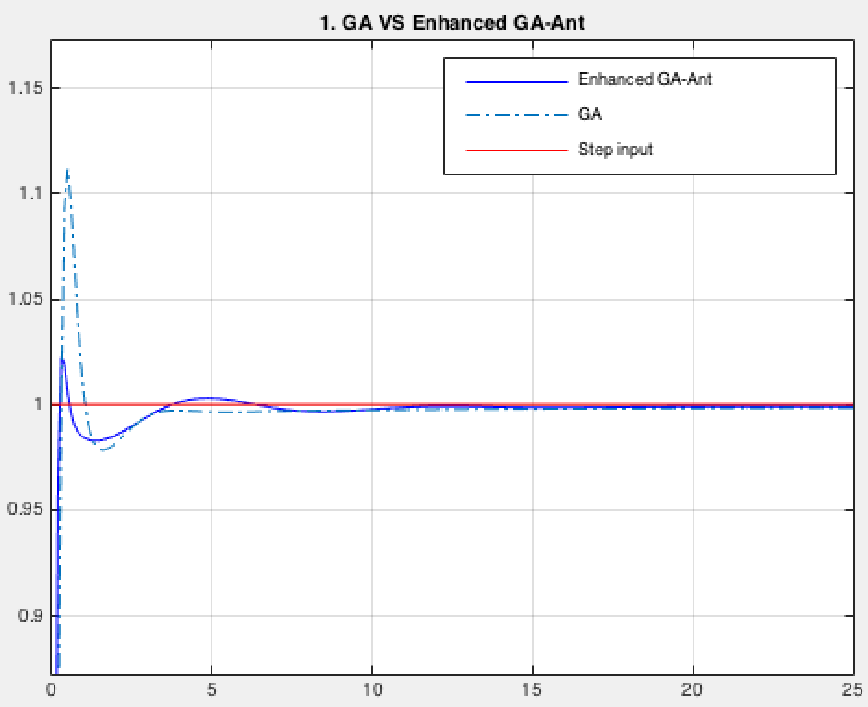

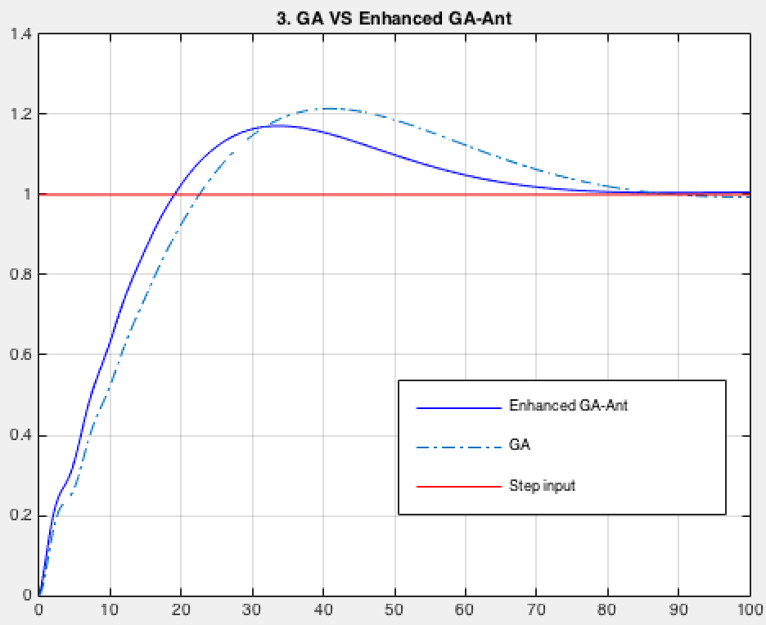

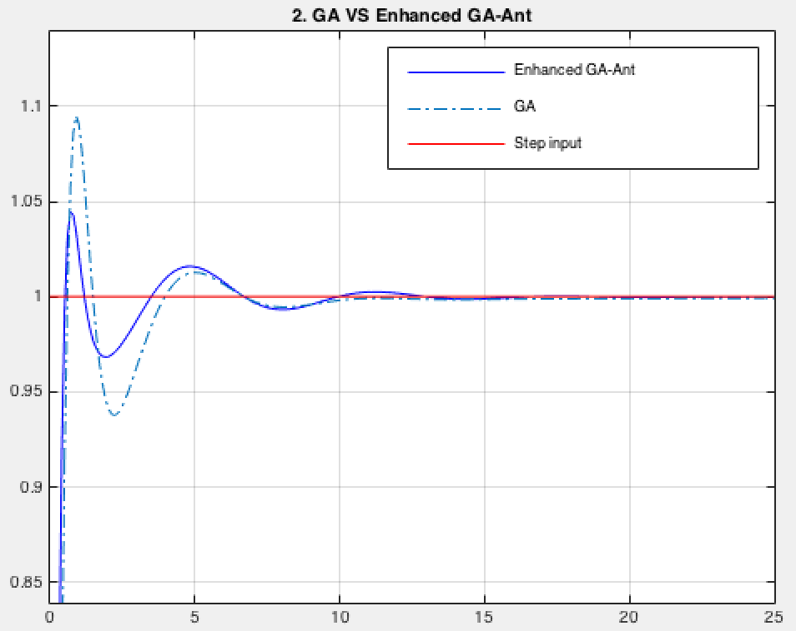

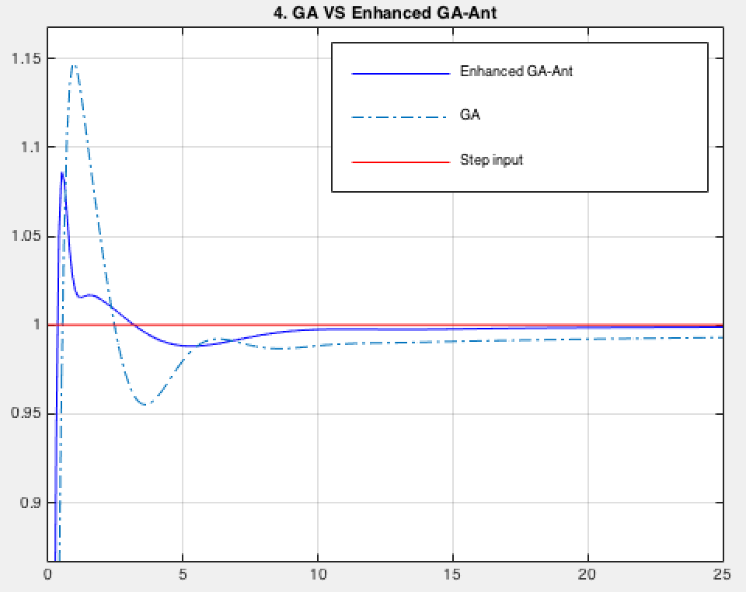

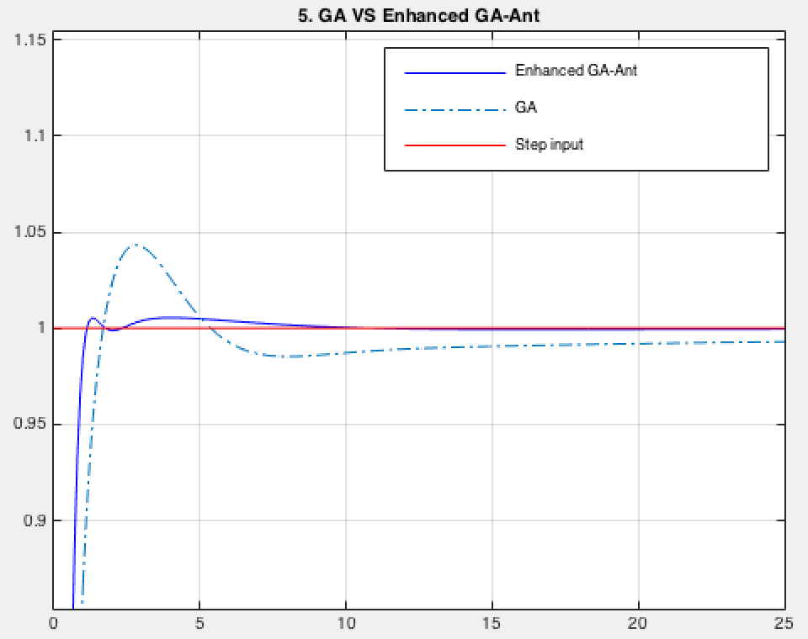

Method | Transfer Function | PID parameters | Time  domain  specs | ITAE
1.  GA | 5  -----------------------  sˆ{2.3}+1.3sˆ{0.9}+1.25 | Kp=1.75  Ki=8.51  Kd=3.63  lam=0.63  mu=0.95 | tr=0.2241  ts=1.8496  O%=11.1550 | 94.3132
Enhanced  Ant GA | 5  -----------------------  sˆ{2.3}+1.3sˆ{0.9}+1.25  Calculated Ant parameters:  α=1.03 β=0.01 ρ=0.18 | Kp=0.07  Ki=8.51  Kd=9.81  lam=0.7136  mu=0.98811 | tr=0.1620  ts=0.3724  O%=2.2403 | 26.6979
2  GA | 1  -----------------------  0.8sˆ{2.2}+0.5sˆ{0.9}+1 | Kp=0.87  Ki=5.59  Kd=4.71  lam=0.91  mu=0.83 | tr=0.4396  ts=3.3795  O%=9.5045 | 9.3791
Enhanced  Ant GA | 1  -----------------------  0.8sˆ{2.2}+0.5sˆ{0.9}+1  Calculated Ant parameters:  α=0.69 β=0.17 ρ=0.93 | Kp=1.41  Ki=7.41  Kd=6.92  lam=0.97324  mu=0.91676 | tr=0.3564  ts=2.6900  O%=4.4471 | 8.2715
3  GA | s+1  ---------------------------------  10sˆ{3.2}+185sˆ{2.5}+288sˆ{0.7}+1 | Kp=8.0700  Ki=4.8300  Kd=4.7500  lam= 0.8700  mu=0.1500 | tr=17.8544  ts=80.2860  O%=21.4689 | 8.3768E+03
Enhanced  Ant GA | s+1  ---------------------------------  10sˆ{3.2}+185sˆ{2.5}+288sˆ{0.7}+1  Calculated Ant parameters:  α=1.71 β=0.03 ρ=1.71 | Kp=9.91  Ki=8.34  Kd=6.7  lam=0.78495  mu=0.81468 | tr=14.8951  ts=69.5422  O%=17.1611 | 6.4081E+03
4  GA | 5sˆ{0.6}+2  ---------------------------------------------  sˆ{3.3}+3.1sˆ{2.6}+2.89sˆ{1.9}+2.5sˆ{1.4}+1.2 | Kp=1.01  Ki=6.21  Kd=4.05  lam=0.59  mu=0.99 | tr=0.3957  ts=4.9944  O%=14.6938 | 282.7508
Enhanced  Ant GA | 5sˆ{0.6}+2  ---------------------------------------------  sˆ{3.3}+3.1sˆ{2.6}+2.89sˆ{1.9}+2.5sˆ{1.4}+1.2  Calculated Ant parameters:  α=0.58 β=0.02 ρ=0.02 | Kp=5.78  Ki=5.78  Kd=9.26  lam=0.90982  mu=0.97523 | tr=0.2554  ts=0.9952  O%=8.6115 | 27.0871
5  GA | 1  -------------------------------  sˆ{2.3}+3.2sˆ{1.4}+2.4sˆ{0.9}+1 | Kp=2.55  Ki=5.75  Kd=6.39  lam=0.67  mu=0.67 | tr=1.0054  ts=4.2681  O%=4.3268 | 44.2226
Enhanced  Ant GA | 1  -------------------------------  sˆ{2.3}+3.2sˆ{1.4}+2.4sˆ{0.9}+1  Calculated Ant parameters:  α=1.3 β=0.34 ρ=1.86 | Kp=9.17  Ki=3.72  Kd=7.84  lam=0.96333  mu=0.60955 | tr=0.6554  ts=0.9715  O%=0.5430 | 11.9839
7. Conclusions

The proposed Enhanced Ant-GA algorithm
improves the response of the system and the robustness of the ACO algorithm, as compared to the classical method, Genetic Algorithm. The
computation time however increases making the algorithm less useful in real time situations.
The algorithm sacrifices on computation time to improve accuracy.

References

[1]

